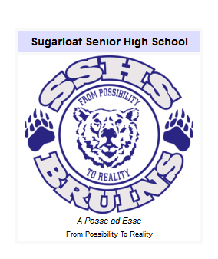
201 Dover Street
Campbellton, N.B.
E3N 1R3
506 789 2125

Sept 5, 2017

Dear Parents,
I have been teaching High School since 2001. I transferred into education from a previous career as a professional geologist in the mineral exploration industry. I feel it is my job to design and provide a course that is challenging, interesting, and authentic. I strive to foster a positive learning environment where all students feel safe, welcomed and valued.
I believe effective communication is essential to building strong relationships and promoting a positive learning environment. I am looking forward to working with you and your child. If you ever have questions or concerns, please contact me by e-mail or phone. If you prefer to phone please call the school (789-2125) and leave a message with the school secretary. I will return your call as soon as possible.
Reg Felix
reginald.felix@nbed.nb.ca

